DBMS Project

“Key Milestone 3”

Spring 2025

CSE 404L – Database Management Systems Lab



SUBMITTED BY: Hoorish Ahmad

Afreen Nasrullah

Sidrah Ishtiaq

REGISTRATION NUMBER: 22PWCSE2198

22PWCSE2195

22PWCSE2159

BATCH: 24

CLASS SECTION: B

SUBMITTED TO: Engr. Sumayyea Salahuddin

Department of Computer Systems Engineering

University of Engineering and Technology, Peshawar

Database Table:

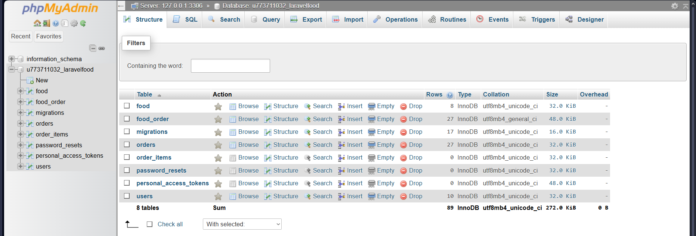

Food:

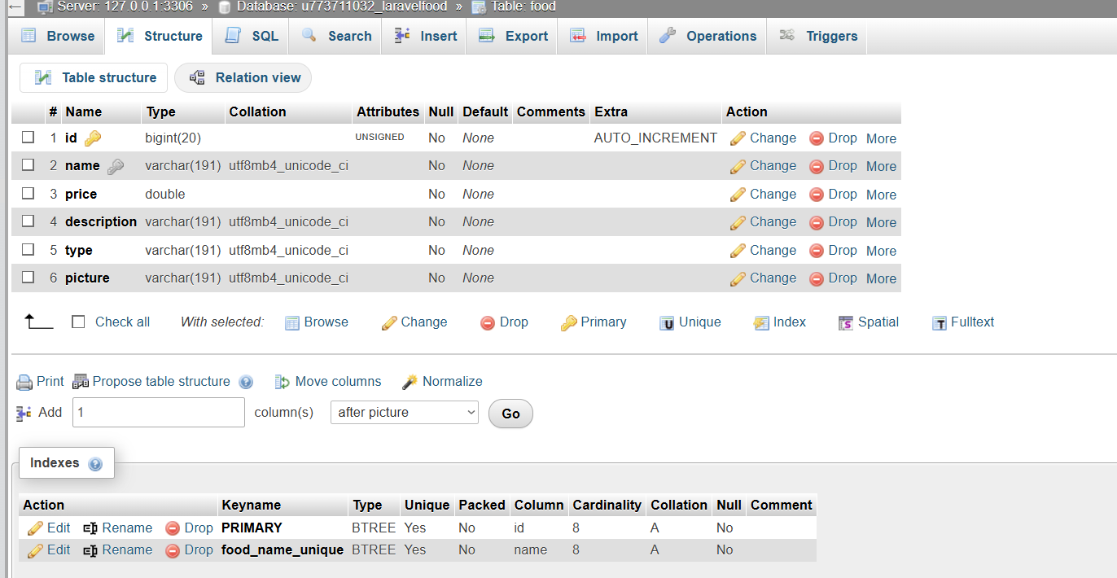

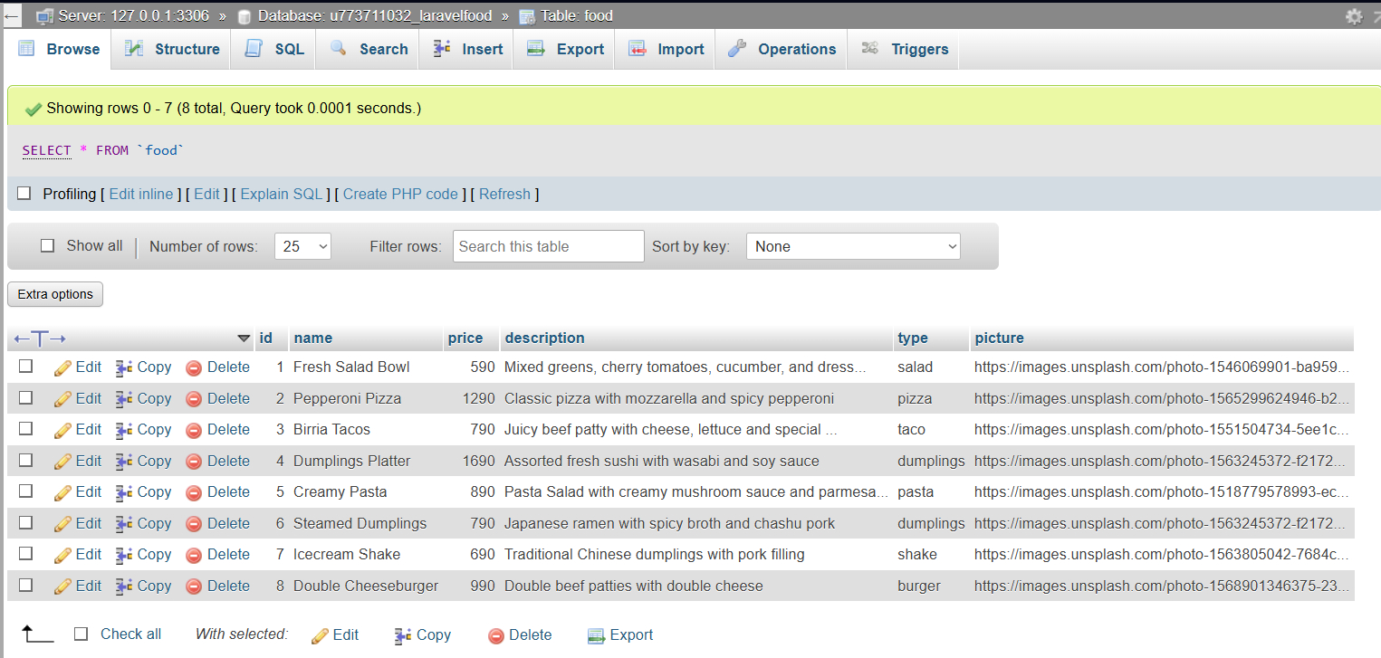Data in tables:

Queries:



Food Order:

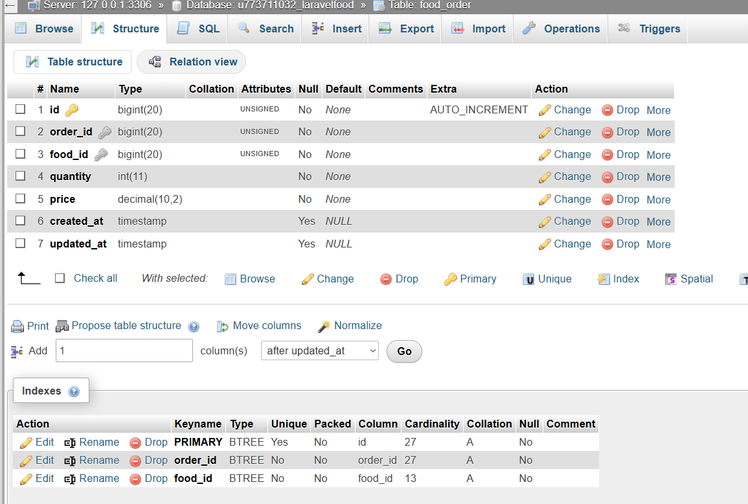

Data in Tables:

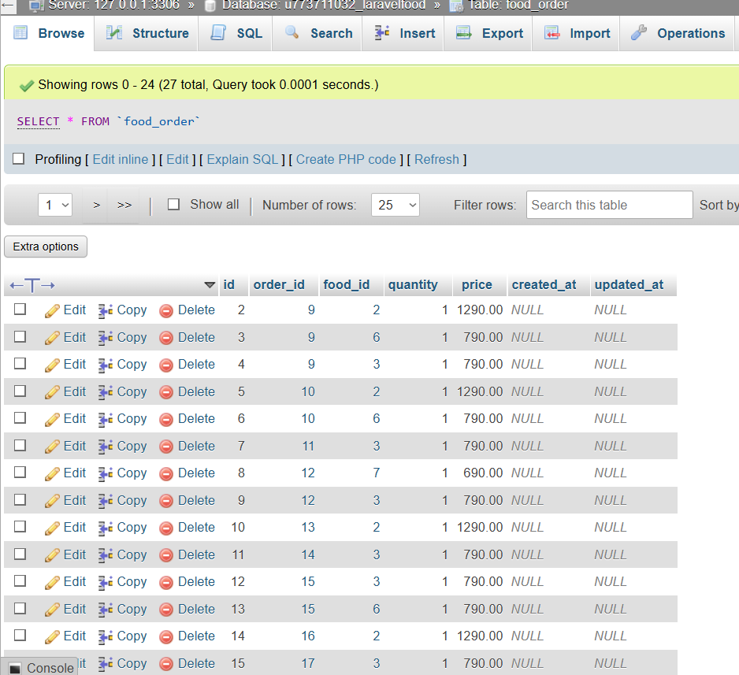

Queries:



Migration:

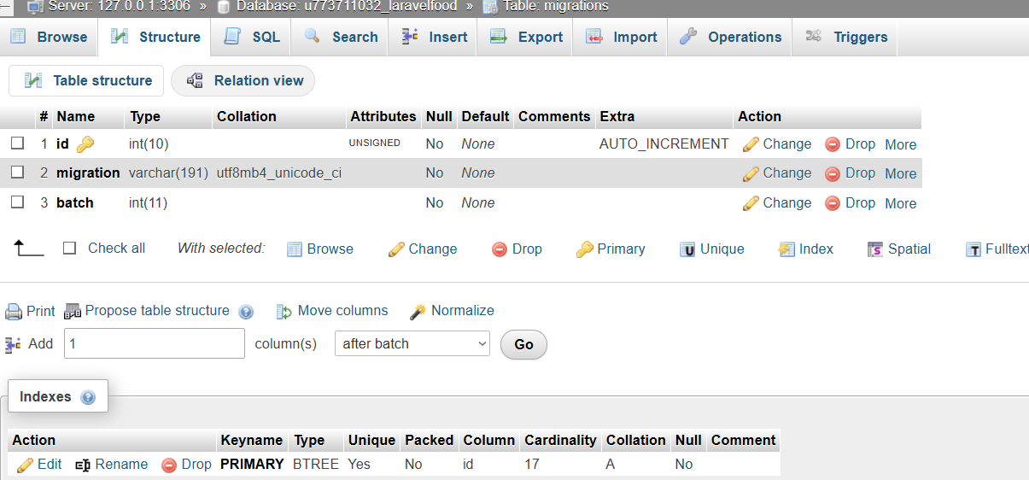

Data in tables: 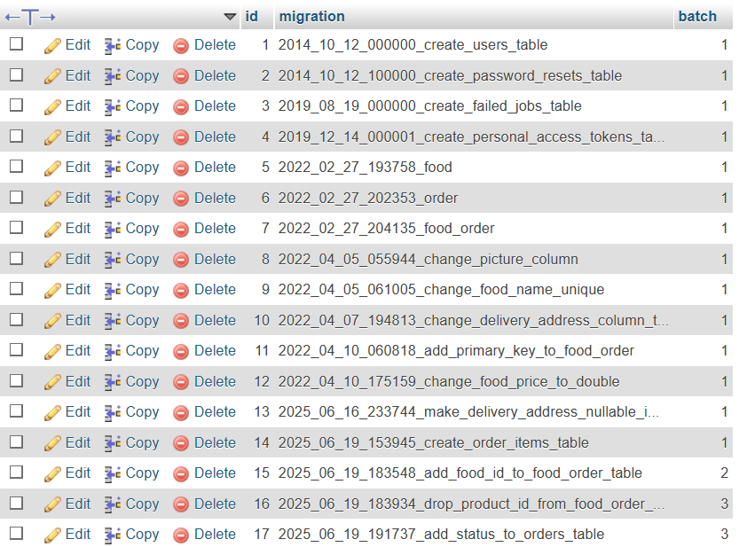

Queries:

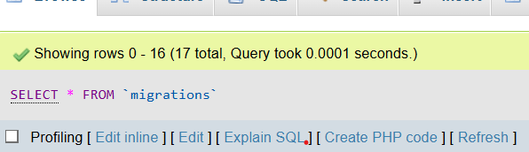

Orders:

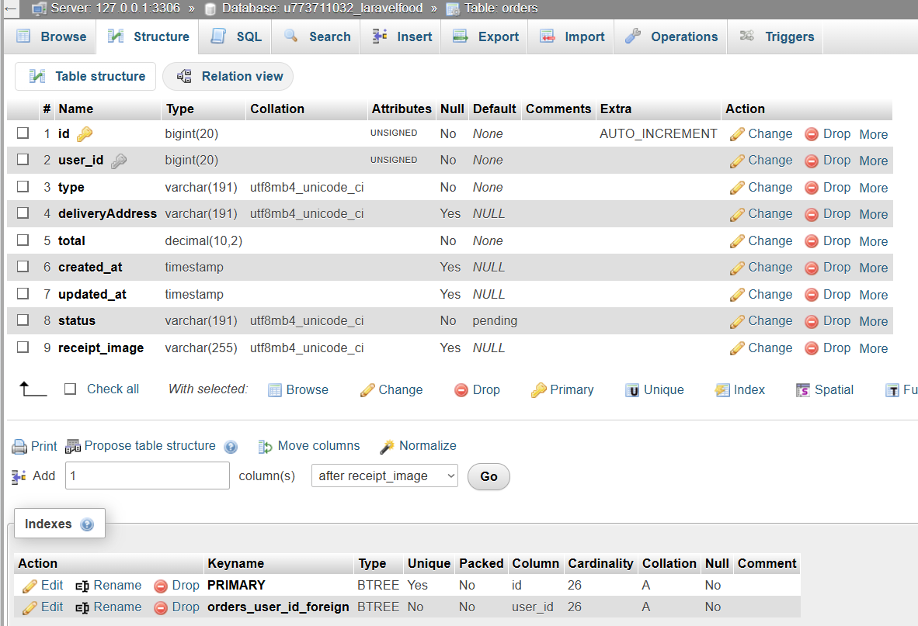

Data in tables: 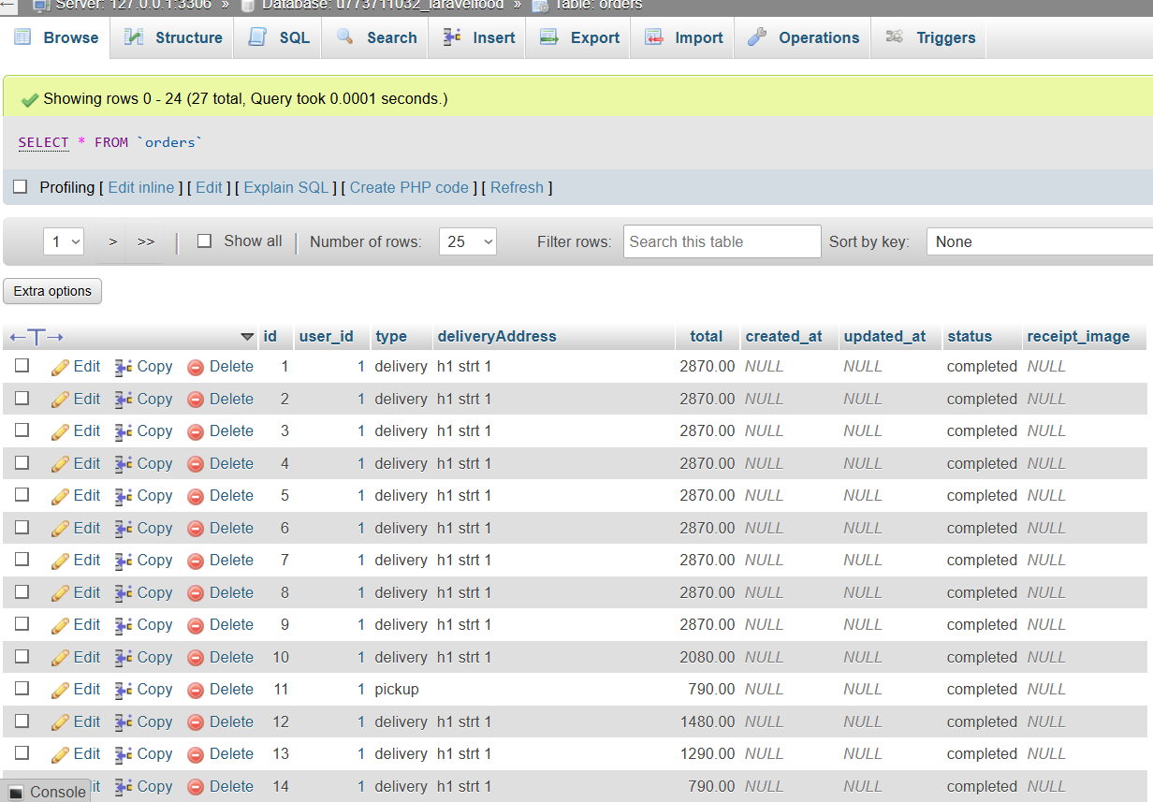

Queries:



Order items:

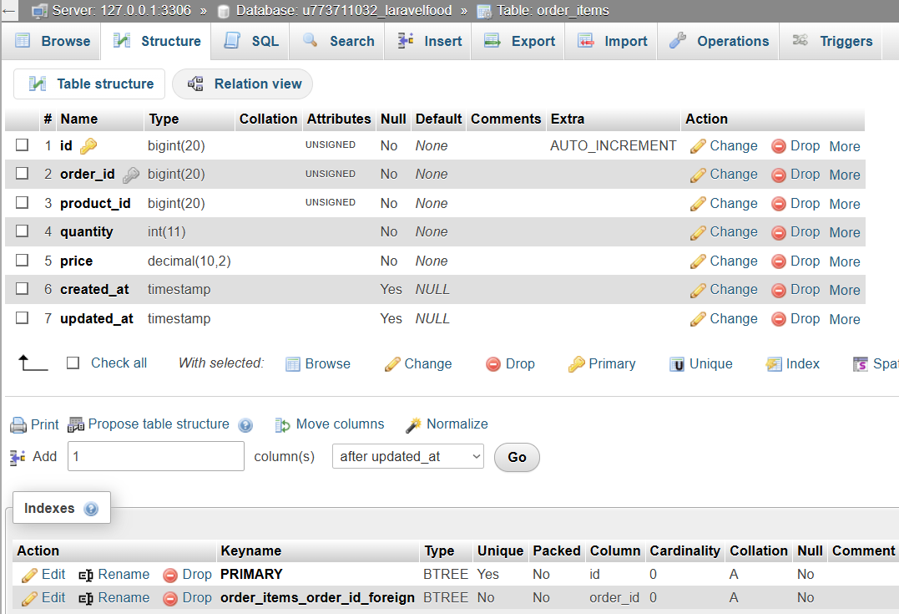

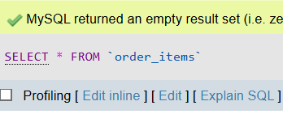Queries:

Password reset:

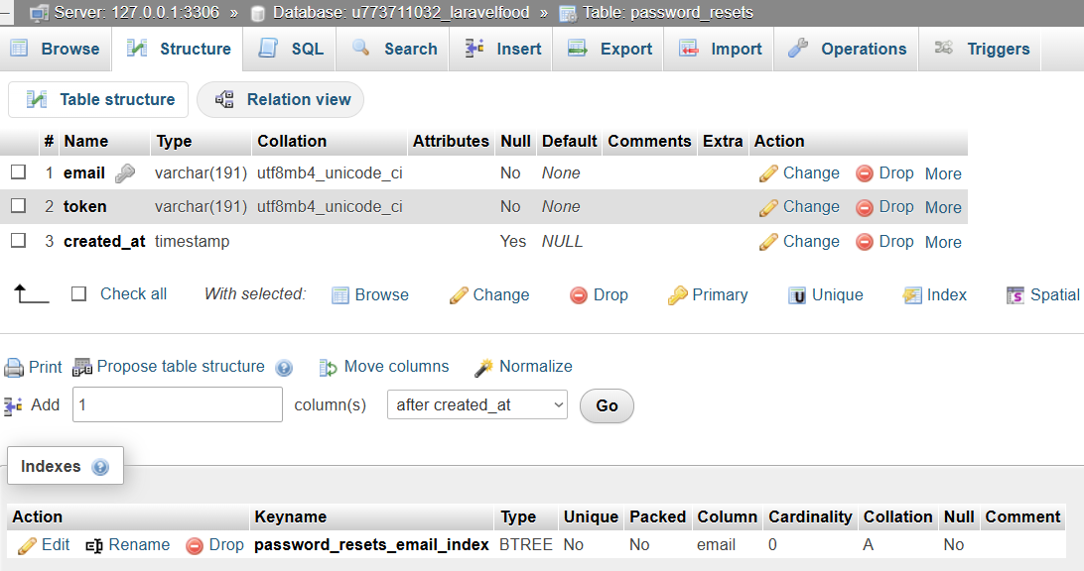

Queries:

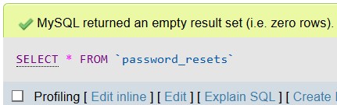

Users:

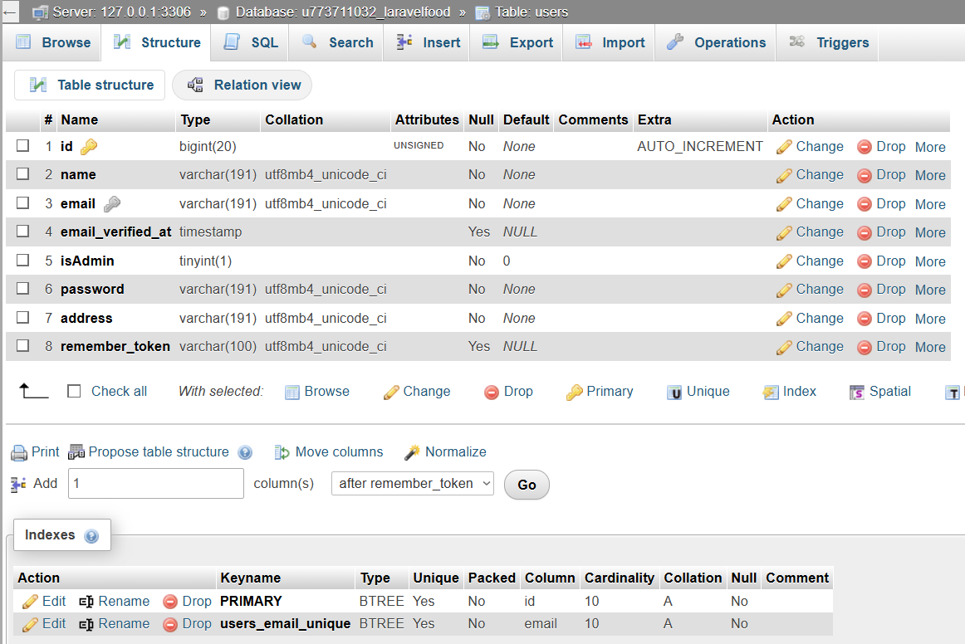

Data in table:

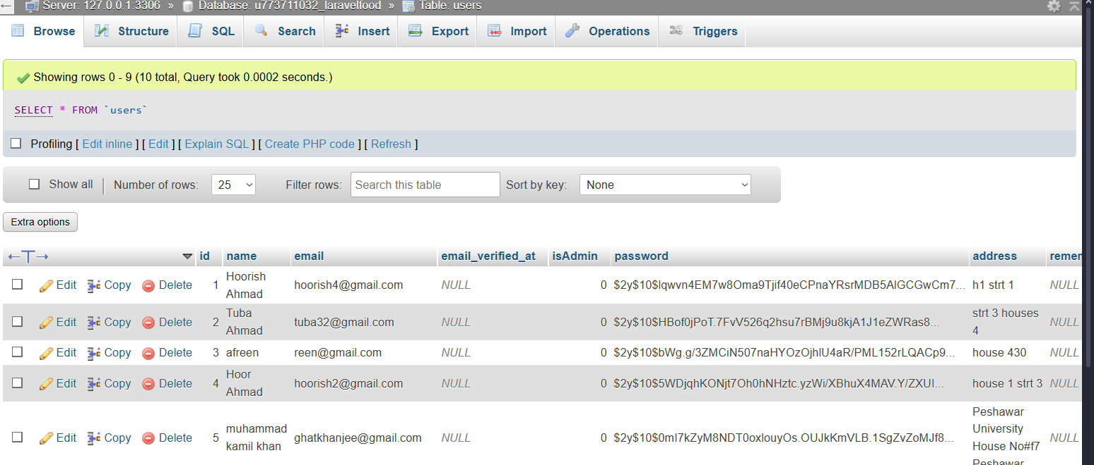

Query:



SQL Code File:

Attached with this .docx file